Full backup and full recovery step
1. Open MySQL Workbench
2. Click MySQL connection
3. Connect to database
4. On Top Menu: Select Server -->Server status
5. Look for Base Directory and Copy the path
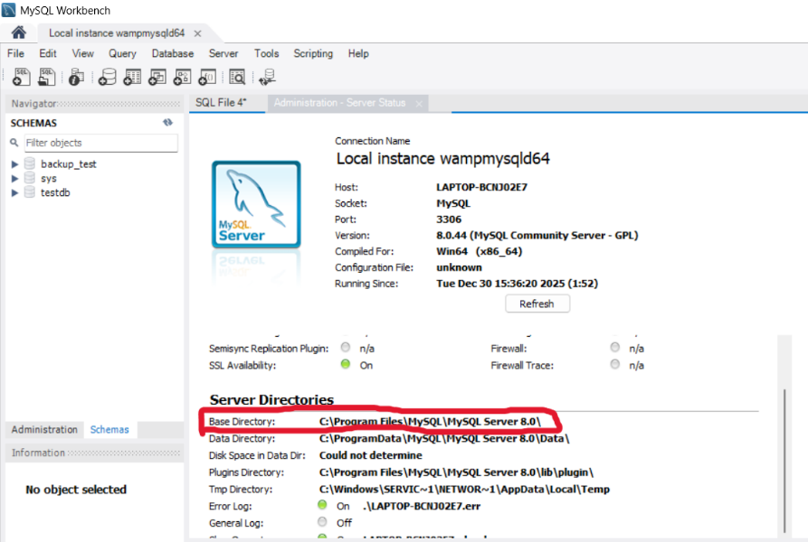

6. Open Command Prompt and run as administrator
7. Run this command to use the database, Add word “bin” at the end of the path to use database.
cd "C:\Program Files\MySQL\MySQL Server 8.0\bin"


8. Go MySQL Workbench, Create database
CREATE DATABASE testdb;
USE testdb;

9. Create table and insert sample data (For this practical testing is 100mb, so run the insert query 10 times)

CREATE TABLE test_10mb (
id INT AUTO_INCREMENT PRIMARY KEY,
payload LONGBLOB
) ENGINE=InnoDB;

INSERT INTO test_10mb (payload)
SELECT REPEAT(0x41, 10485760);
SELECT
ROUND(SUM(LENGTH(payload))/1024/1024, 2) AS total_mb
FROM test_10mb;
10. Check the table exist in MySQL Workbench or using command below in cmd
mysql -u root -p testdb -e "SELECT COUNT(*) FROM test_10mb;"

11. Create backup folder or run this command **Can create in any path except in program file
mkdir C:\Users\User\Documents\mysql_backup

12. Run this command to FULL BACKUP
mysqldump -u root -p testdb >C:\Users\User\Documents\mysql_backup\full_backup.sql

**Nothing happen = backup successful

13. Verify file exists
dir C:\Users\User\Documents\mysql_backup
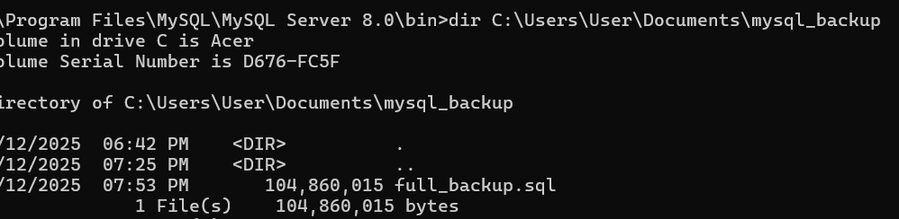

14. Simulate database failure by dropping the database and recreate. (Clean all the data in the database) *** You will not see any data in database for now
mysql -u root -p -e "DROP DATABASE testdb; CREATE DATABASE testdb;"

15. Perform Full Recovery and measure the time (Create a .bak file with notepad to record time by system – For more accurate time) Put the note below inside the .bak file and name as recover_time.bat ***Must change the path accordingly
@echo off
set start=%time%
"C:\Program Files\MySQL\MySQL Server 8.0\bin\mysql.exe" --login-path=local testdb < C:\Users\User\Documents\mysql_backup\full_backup.sql
set end=%time%
echo Recovery start time: %start%
echo Recovery end time: %end%
pause

16. After create .bak file, put the file at the location same as the mysql_backup. Then run the command below.
C:\Users\User\Documents\recover_time.bat
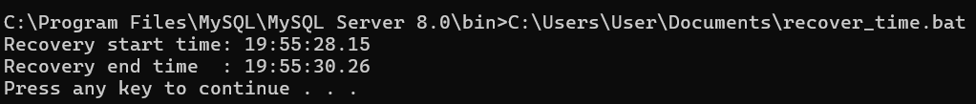

16. Verify Recovery
dir C:\Users\User\Documents\mysql_backup
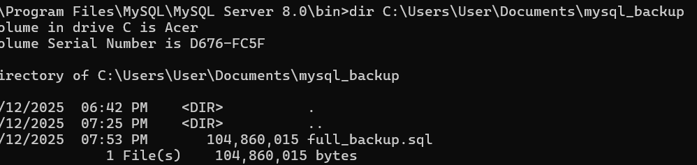

Incremental Backup and Recovery
1. Select the correct path then Check binlog status (must be on)
cd "C:\Program Files\MySQL\MySQL Server 8.0\bin"
mysql --login-path=local -e "SHOW VARIABLES LIKE 'log_bin';"
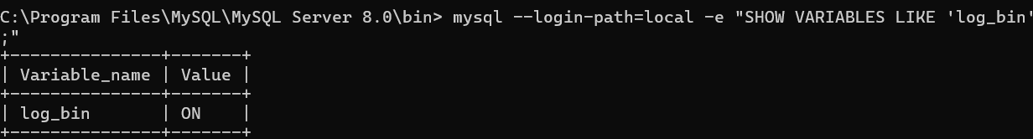
*******ONLY PERFORM THIS STEP IF BINLOG IS OFF
1. C:\ProgramData\MySQL\MySQL Server 8.0\my.ini
2. Add under [mysqld]
log-bin
server-id=1
3. Save and restart MySQL (Can run in cmd)
net stop MySQL80
net start MySQL80
4. Then Go back to Step 1 Check binlog status
2. Then do the same step as the FULL BACKUP create table and insert data in MySql Workbench

DROP DATABASE IF EXISTS testdb;
CREATE DATABASE testdb;
USE testdb;

CREATE TABLE test_10mb (
id INT AUTO_INCREMENT PRIMARY KEY,
payload LONGBLOB
) ENGINE=InnoDB;

****this can insert 50mb once
INSERT INTO test_10mb (payload)
SELECT REPEAT(0x41, 52428800);
SELECT
ROUND(SUM(LENGTH(payload))/1024/1024, 2) AS total_mb
FROM test_10mb;

2.1 Verify Table
mysql -u root -p testdb -e "SELECT COUNT(*) FROM test_10mb;"
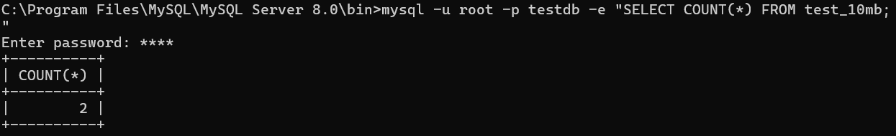

3. Perform Full Backup
mysqldump -u root -p testdb >C:\Users\User\Documents\mysql_backup\full_backup.sql

4. Flush logs (Record binlog) ****Must do otherwise cannot find the latest change in database
mysql --login-path=local -e "FLUSH LOGS;"

5. Insert New Data ( For Incremental Backup purpose ) Initial 100MB, Now add 10mb
INSERT INTO test_10mb (payload)
SELECT REPEAT(0x41, 10485760);
SELECT
ROUND(SUM(LENGTH(payload))/1024/1024, 2) AS total_mb
FROM test_10mb;

6. Verify Table
mysql -u root -p testdb -e "SELECT COUNT(*) FROM test_10mb;"
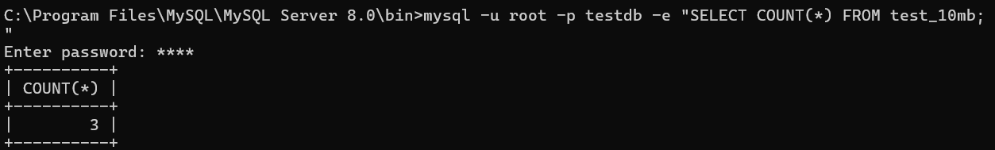

7.Find binlog path
mysql --login-path=local -e "SHOW VARIABLES LIKE 'log_bin_basename';"
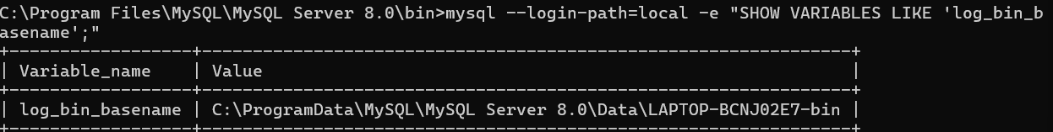

8. List out (Incremental backup)
dir "C:\ProgramData\MySQL\MySQL Server 8.0\Data\*bin.*"

9. Copy the latest one and store in the backup file ****Don’t copy the .index
copy "C:\ProgramData\MySQL\MySQL Server 8.0\Data\LAPTOP-BCNJ02E7-bin.000032" C:\Users\User\Documents\mysql_backup\

10. Simulate database failure
mysql --login-path=local -e "DROP DATABASE testdb; CREATE DATABASE testdb;"
11. Convert binlog to sql (prepare incremental recovery file) **sql unable to recovery a binlog file
mysqlbinlog "C:\Users\User\Documents\mysql_backup\LAPTOP-BCNJ02E7-bin.000022" > "C:\Users\User\Documents\mysql_backup\incremental.sql"
12. Perform Incremental recovery and measure the time (Create a .bak file with notepad to record time by system – For more accurate time) Put the note below inside the .bak file and name as incremental_recover_time.bat ***Must change the path accordingly
@echo off
set start=%time%
"C:\Program Files\MySQL\MySQL Server 8.0\bin\mysql.exe" --login-path=local testdb < C:\Users\User\Documents\mysql_backup\incremental.sql
set end=%time%
echo Incremental recovery start time: %start%
echo Incremental recovery end time: %end%
pause

13. Restore the original file first.
mysql --login-path=local testdb < C:\Users\User\Documents\mysql_backup\full_backup.sql
or
C:\Users\User\Documents\recover_time.bat

14. Verify Table
mysql --login-path=local testdb -e "SHOW TABLES;"
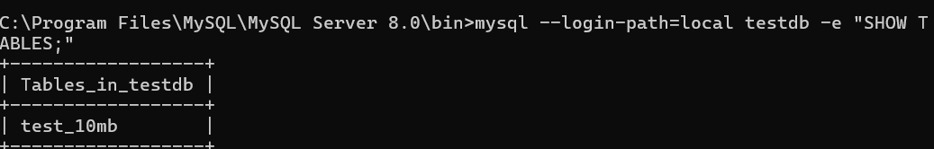

15. Run the command below in cmd
C:\Users\User\Documents\incremental_recovery.bat

16. Verify Recovery in cmd or Sql Workbench. (The file size remain the same) 110MB
dir C:\Users\User\Documents\mysql_backup

SELECT
ROUND(SUM(LENGTH(payload))/1024/1024, 2) AS total_mb
FROM test_10mb;

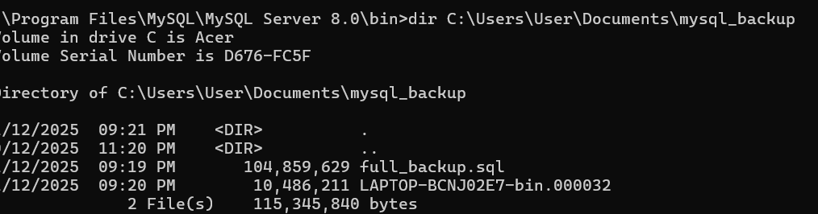

AFTER

